**Service ID**: WP3-01

**300 mm SOI platform at CEA**

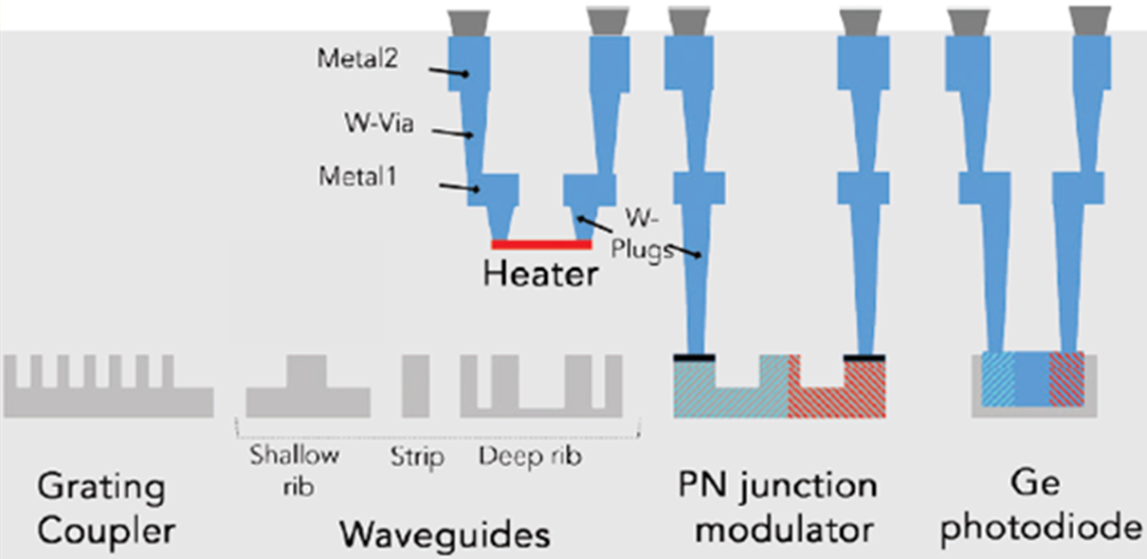

**Overview**

CEA-Leti’s offers a versatile SOI photonics platform on 300 mm SOI wafers that leverages world-class pre-industrialization equipment. It includes key integrated components for quantum light generation, manipulation and detection. It also offers enabling technology based on classical PICs for applications based on non-photonic quantum platforms.

**Field of Application and applied technology**

Quantum communications, quantum computing, quantum sensing

**Specifications**

Technological features

* 300 mm SOI substrates with 310 nm Si and 2 µm buried oxide
* Implant for active devices
* Multilevel patterning with immersion lithography @ 193 nm
* 2 metal layers

Device library @ 1550 nm

* Light generation : sources of photon pairs based on spontaneous four-wave mixing
* Light manipulation with passive components : low-loss waveguides, filters, mux/demux
* Light manipulation with active components : thermo-optical phase shifters and switches, high-speed modulators based on plasma dispersion, variable attenuators
* Light detection : high-speed Ge photodetectors, NbN superconducting single photon detectors
* I/O : 1D and 2D grating couplers, spot-size converters

A large number of devices are available in the PDK. CEA also offers some flexibility to design custom building blocks according to partner specification requirements.

Circuit design

Circuit design and layout can be provided by CEA along partner specification requirements using PDK or custom building blocks.

Alternatively, circuits can be designed by the external partner using CEA’s PDK available using Cadence or Luceda design platforms.

Testing

CEA-LETI’s world-class testing facilities include several automated wafer-level measurements for optical and electro-optical meausrements in the classical regime

Packaging

Fiber array attachement and electrical wire bonding on PCB